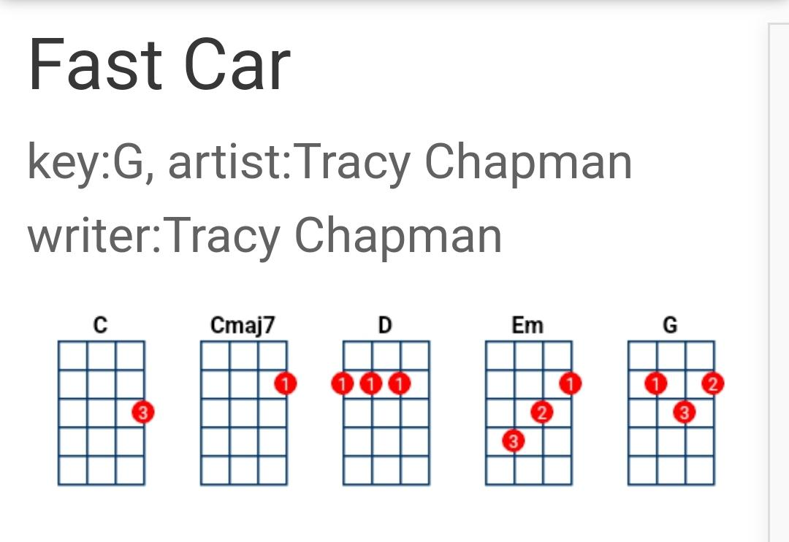
Cmaj7 G Em D x4

Cmaj7 G
You got a fast car.
Em D
I want a ticket to anywhere.
Cmaj7 G
Maybe we make a deal,
Em D
Maybe together we can get somewhere.
Cmaj7 G
Any place is better.
Em D
Starting from zero, got nothing to lose.
Cmaj7 G
Maybe we'll make something,
Em D
Me myself, I got nothing to prove.

Cmaj7 G Em D X2

Cmaj7 G
You got a fast car.
Em D
I got a plan to get us out of here:
Cmaj7 G
I been working at the convenience store,
Em D
Managed to save just a little bit of money.
Cmaj7 G
Won't have to drive too far

Em D
Just 'cross the border and into the city,
Cmaj7 G
You and I can both get jobs
Em D
And finally see what it means to be living.

Cmaj7 G Em D X2

Cmaj7 G
You see, my old man's got a problem:
Em D
He live with the bottle, that's the way it is.
Cmaj7 G
He says his body's too old for working,
Em D
His body's too young to look like his.
Cmaj7 G
My mama went off and left him,
Em D
she wanted more from life than he could give,
Cmaj7 G
I said, "Somebody's got to take care of him."
Em D
So I quit school and that's what I did.

Cmaj7 G Em D X2

Cmaj7 G
You got a fast car.
Em D
But is it fast enough so we can fly away?
Cmaj7 G
We gotta make a decision:
Em D
Leave tonight or live and die this way.

Cmaj7 G Em D X2

D Cmaj7 G
So I remember when: we were driving, driving in your car,
Cmaj7 G
The speed so fast I felt like I was drunk,
Em C
City lights lay out before us
Em D
And your arm felt nice wrapped 'round my shoulder.
C Em D
And I had a feeling that I belonged
C Em D Em G Em
And I had a feeling I could -- be someone, be someone, be someone.

Cmaj7 G Em D X2

Cmaj7 G
You got a fast car
Em D
And we go cruising to entertain ourselves;
Cmaj7 G
you still ain't got a job
Em D
And I work in a market as a checkout girl.
Cmaj7 G
I know things will get better:
Em D
You'll find work and I'll get promoted,
Cmaj7 G
We'll move out of the shelter
Em D
Buy a bigger house and live in the suburbs.

Cmaj7 G Em D X2

D Cmaj7 G
So I remember when: we were driving, driving in your car,
Cmaj7 G
The speed so fast I felt like I was drunk,
Em C
City lights lay out before us
Em D
And your arm felt nice wrapped 'round my shoulder.
C Em D
And I had a feeling that I belonged
C Em D Em G Em
And I had a feeling I could -- be someone, be someone, be someone.

Cmaj7 G Em D X2

Cmaj7 G
You got a fast car.
Em D
And I got a job that pays all our bills.

Cmaj7 G
You stay out drinking late at the bar,
Em D
You see more your friends than you do your kids.
Cmaj7 G
I'd always hoped for better,
Em D
Thought maybe together you and me would find it,
Cmaj7 G
I got no plans I ain't going nowhere,
Em D
so take your fast car and keep on driving.

Cmaj7 G Em D X2

D Cmaj7 G
So I remember when: we were driving, driving in your car,
Cmaj7 G
The speed so fast I felt like I was drunk,
Em C
City lights lay out before us
Em D
And your arm felt nice wrapped 'round my shoulder.
C Em D
And I had a feeling that I belonged
C Em D Em G Em
And I had a feeling I could -- be someone, be someone, be someone.

Cmaj7 G Em D X2

Cmaj7 G
You got a fast car.
Em D
But is it fast enough so we can fly away?
Cmaj7 G
We gotta make a decision:
Em D
Leave tonight or live and die this way.

Cmaj7 G Em D x3

Cmaj7 G

Source: www.ukulele-tabs.com

