Still Gonna Die Lyrics by Sid Silverstein

[Intro] (Pluck single strings in the chords, absentmindedly)
A: So you're taking better [F] CARE of your body. Becoming more AWARE of your body
B: [G] Responding to your body's NEEDS. Everything you hear and READ
C: …about [C] diets, nutrition, and sleeping position
and [E] detoxifying your system and buying maCHINES…
D: …that they advertise to help you exercise
E: [Dm] Herbs to [D] revitalize you if you're traumatized
F: [G] Soaps that will sanitize
G: Sprays to [C] deodorize
H: Liquids to neutralize acids and pesticides
I: [D] Free weights to maximize your [Fm] strength and muscle size
J: Shots that will [C] immunize Pills to [G] re-energize you
K: But remember that for all your pain and [F] gain… Eventually…. the story ends…
(ALL): the [G] SAME!

All - [Verse 1]
C G G7 C
SO you can quit smokin', but you're still gonna die. Cut out cokin' but you're still gonna die
C C7 F FM7 G G7 C
Eliminate everything fatty or fried, And you'll get real healthy, but you're still gonna die

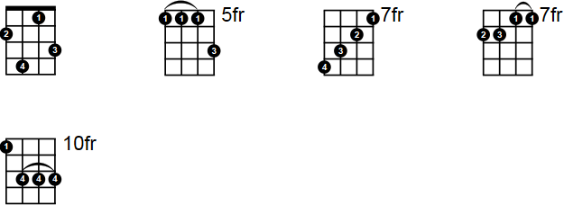
L - [Verse 2]
Fmaj7
C G
Stop drinkin' booze and you're still gonna die.
G7 C
(You can) stay away from Coors, and son… you're still gonna die
C C7 F FM7 G G7 C
You can cut out coffee and never get high But you're still gonna, still gonna, still gonna die
All - [Chorus 1]
C G
You're still gonna, still gonna, still gonna die
BA25
G7 C
You're still gonna, still gonna, still gonna die
C C7 F FM7
You can even give aerobics one more try
G G7 C
But when the music stops playin', you're still gonna die

M - [Verse 3]
C G
Put seatbelts in your car… you're still gonna die
G7 C
Cut nicotine tar… you're still gonna die. You can
C C7 F FM7
exercise that cellulite off of your thighs,
G G7 C
Get slimmer and trimmer, but you're still gonna die
N - [Verse 4]
Stop gettin' a tan… you're still gonna die
You can eat a lot of oat bran, but you're still gonna die
You can search for UFOs up in the sky,
They might fly you to Mars where you're still gonna die
All - [Chorus 2]
C G
You're still gonna, still gonna, still gonna die
G7 C
You're still gonna, still gonna, still gonna die
C C7 F FM7
And all the Nikes and Reboks and Adidas you buy
G G7 C
You can jog up to heaven, and you're still gonna die
O - [Verse 5]
C G
Drink ginseng tonics, you're still gonna die
G7 C
Try high colonics, you're still gonna die. You can
C C7 F FM7
have yourself frozen and suspended in time
G G7 C
But when they do thaw you out, HA HA! - You're still gonna die

P - [Verse 6]
C G
You can have safe sex… you're STILL gonna die
G7 C
You can switch to Crest, but you're STILL gonna die
C
You can get rid of stress… and get a lot of rest… get a AIDS test… enroll in EST,
C7 F FM7
And move out west where it's sunny and dry
G G7 C
And you'll live to be a hundred, but you're still gonna die

All - [Chorus 3]
C G
You're still gonna, still gonna, still gonna die
G7 C
You're still gonna, still gonna, still gonna die
C C7 F FM7
So you better have some fun before you say BYE BYE
G
Cuz you’re still gonna, still gonna, still gonna, still gonna
G7 C C\
Still gonna, still gonna, still gonna DIEeyeeeeee (*cough cough cough*)

