A Horse with No Name - America
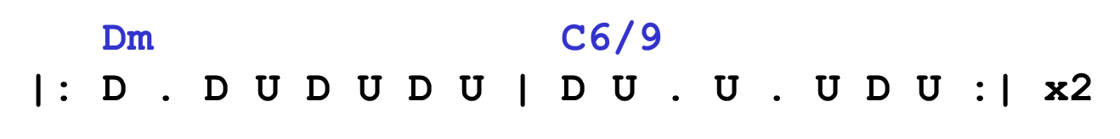

On the [Dm] first part of the [C6/9] journey
I was [Dm] looking at all the [C6/9] life
There were [Dm] plants and birds and [C6/9] rocks and things
There was [Dm] sand and hills and [C6/9] rings
The [Dm] first thing I met was a [C6/9] fly with a buzz
And the [Dm] sky with no [C6/9] clouds
The [Dm] heat was hot and the [C6/9] ground was dry
But the [Dm] air was full of [C6/9] sound

Chorus
I’ve [Dm7] been through the desert on a [Em7] horse with no name
It felt [Dm7] good to be out of the [Em7] rain
In the [Dm7] desert you can re-[Em7]member your name
Cause there [Dm7] ain’t no one for to [Em7] give you no pain
La, [Dm7] la ...

After [Dm] two days in the [C6/9] desert sun
My [Dm] skin began to turn [C6/9] red
After [Dm] three days in the [C6/9] desert fun
I was [Dm] looking at a river [C6/9] bed
And the [Dm] story it told of a [C6/9] river that flowed
Made me [Dm] sad to think it was [C6/9] dead

Repeat Chorus

After [Dm] nine days I let the [C6/9] horse run free
Cause the [Dm] desert had turned to [C6/9] sea
There were [Dm] plants and birds and [C6/9] rocks and things
There was [Dm] sand and hills and [C6/9] rings
The [Dm] ocean is a desert with its [C6/9] life underground
And a [Dm] perfect disguise a-[C6/9]bove
Under the [Dm] cities lies a [C6/9] heart made of ground
But the [Dm] humans will give no [C6/9] love

Repeat Chorus

Chords
Verse
Dm 2210
C6/9 0200

Chorus
Dm7 2213 5555
Em7 4435 7777

Chorus
|: Dm7 | Em7 :|
OR
|: Dm7 | Em7 | Fmaj7 | Em7 :|
Dm7 2213 5555
Em7 4435 7777
Fmaj7 5557

